**LINEAR REGRESSION**

**DEVELOPED BY: VISHRUTH KHARE**

**ROLL NUMBER: 2K18/CO/393**

IDE: PyCharm

Compiler: Terminal (Python 3.6)

DataSet: Salary Dataset

Sample Dataset:

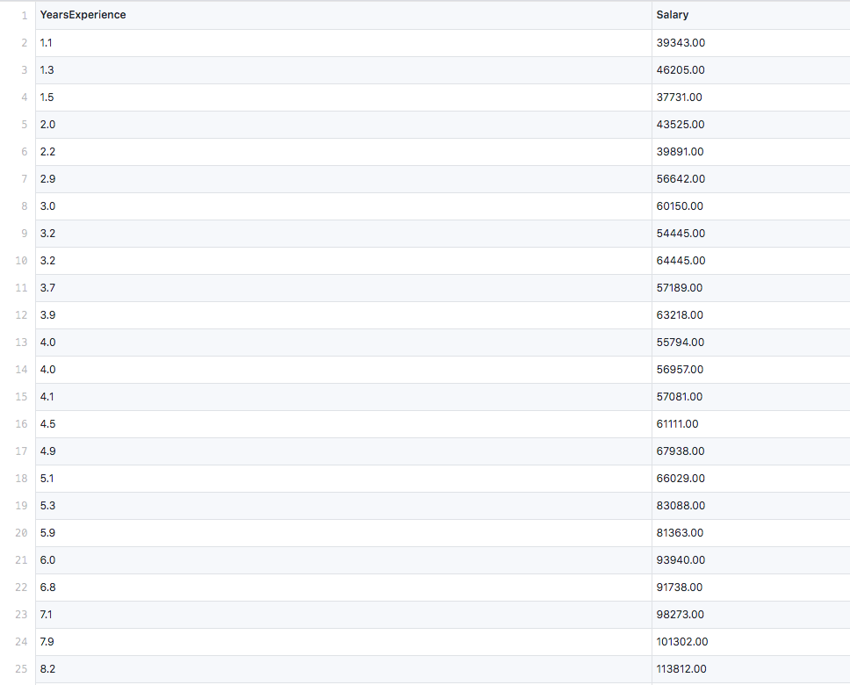

**Source Code:**

**OUTPUT:**

